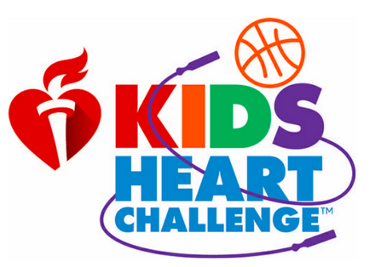
Kids Heart Challenge 2019!
(former known as Jump Rope for Heart)

You may already know that our annual P.E. community service event is almost here! This is Waterloo’s 16th year partnering with the American Heart Association to help children who suffer from heart conditions, while at the same time keeping our heart healthy by honing our jump rope and fitness skills in physical education. We’ll kick off our campaign on January 29th with a pep rally in the afternoon and find out about how to help and get a sneak peek at our incentive “Thank You” gifts. This year’s prizes are called the Heart Heroes and feature friendly characters that clip onto your backpack and have names like Echo, Finn, Ruby and Oscar to to name a few.

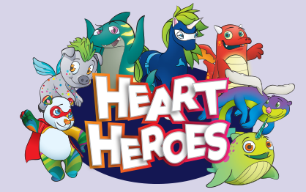

You can register online by clicking this direct link: http://www2.heart.org/goto/waterloo

Or going to http://american.heart.org/kidsheartchallenge/ and following the prompts.

ANYONE STUDENT WHO REGISTERS ONLINE will receive a FREE glow wristband (you don’t have to earn any money). We are encouraging all children to gather donations online or by mobile app and are discouraging cash donations if at all possible. Checks should be made out to: American Heart Association

Our first incentive offering is to raise $150 before our January 29th Pep Rally and you will receive a plush pillow FINN during the assembly. Last year we had 15 students complete this goal!
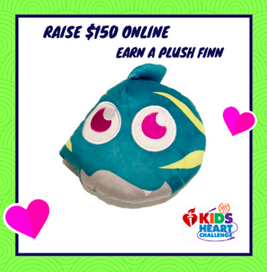

Final donation packet return is no later than March 1st but we would strongly encourage students to turn in their donations prior to the last day. We’ll celebrate our heart healthy lessons in P.E. during the week of February 25th through March 1st with all things jumping… pogo sticks, vertical jumps, hoppity-hops, double dutch, skip-it’s and so much more!

