Waterloo Elementary School PTA
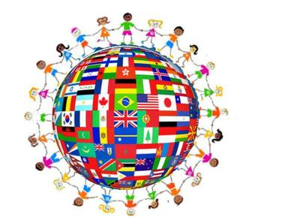
International Night

International Night is coming up on Friday, February 24, 2017 from 6:30-8:30 pm (snow date TBD). All students, staff, and parents are welcome to attend. This is a free, family night of fun as we highlight the many cultures of Waterloo, as well as other places around the world. There will be tasty treats, booths representing various countries, activities, and mini-concerts.
If you are interested in presenting food from your native culture for others to taste, please contact International Night food coordinator, Rob Burks, at waterloointernationalnight@gmail.com by Monday, January 30, 2017.
*Food station set-ups will begin at 6 pm on the night of the event
__________________________________________________________________
Name________________________ Student name________________________
Phone________________________ Email________________________ _______
Type of food dish____________________________________________________
Special requests for Waterloo PTA ______________________________________
__________________________________________________________________

