FIELD DAY IS FRIDAY, May 11th (Rain Date; Thursday, May 17th)
Join us for our annual Field Day full of fun, sun and even better sportsmanship.
We need 90 parents to help make this a memorable and fun day for all 650 Waterloo students. Please consider donating a few hours for our morning session which runs from 9:30-12:10 or our afternoon session, which runs from 12:10-2:50. We wouldn’t say “no” if you decided to help the entire day Pack your sunscreen, water bottle and a bagged lunch to get in on the fun. You can access the schedule below while you go online to catch a glimpse of your own child as well.
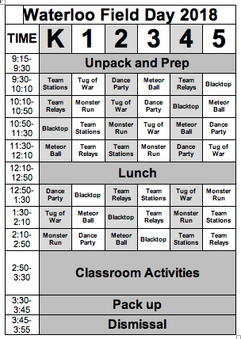

DIRECTIONS for Electronic Sign Up to volunteer Friday, May 11th:
1. http://www.signupgenius.com/go/20f0549aea929a46-field4
2. Enter Access Code: field day

