January 22, 2018-ALL DAY!

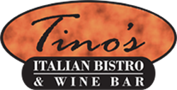

8775 Centre Park Drive
Columbia, MD
410-730-TINO (8466)
Bring your family to Tino’s on January 22nd, and Waterloo will receive 10% of your
purchase cost! Enjoy great food while supporting the PTA.
REMEMBER TO TAKE THIS FLYER WITH YOU!
If you can, please make a reservation and mention the fundraiser!

January 22, 2018-ALL DAY!

8775 Centre Park Drive
Columbia, MD
410-730-TINO (8466)
Bring your family to Tino’s on January 22nd, and Waterloo will receive 10% of your
purchase cost! Enjoy great food while supporting the PTA.
REMEMBER TO TAKE THIS FLYER WITH YOU!
If you can, please make a reservation and mention the fundraiser!

